Following a tumultuous year, we are very pleased to once again invite applications for artist residencies at our studio in Wellington Road, Portslade, Brighton. We have three eight-week options beginning in August 2021 and running through to March 2022. We understand that you may not be able, or want to, travel at the moment and so we are offering the option of in person or remote residencies.
All in person residencies will be run in line with government guidelines and we are taking all precautions necessary to make the space as safe as possible for our residents, staff and tenants. We regularly review and update our procedures in line with current guidelines.
The three options to choose from are:
- 23 August to 15 October 2021
- 18 October to 11 December 2021
- 7 February to 1 April 2022
We are inviting applications via SurveyMonkey but if you prefer to apply with an audio or video application, or phone call, please contact dan (@) blasttheory.co.uk
- Deadline for applications: Monday 5th July midday UK time (strict deadline)
- Shortlisted applicants will be invited to interview on Monday 12th July
- Successful applicants will be notified by Wednesday 14th July
Please access the online application by clicking this link (opens a new page).

Overview
This unique Residency Programme is initiated and run by the artists in Blast Theory: Ju, Matt and Nick. It provides a studio space, accommodation, and uninterrupted time for residents to research and develop new work in a supportive environment.
With almost 30 years' experience as an artist-led company, we have a wealth of skills to support practitioners from all backgrounds and stages in their career; supporting skills development, providing opportunities and nurturing talent.

Our support
Blast Theory encourages debate and exchange with residents throughout the residency. We can offer the following to residents and we take our lead from the needs of each resident:
- Mentoring sessions with a Blast Theory artist
- Professional advice
- Insights into the company’s history, practice, research & development activities, working methods, business structure and artistic structure
- Access to equipment and resources
- Networking opportunities
We tailor support to individual needs: in the past this has included running workshops, tests, works in progress and talks to the Blast Theory team and invited guests.
We strive to provide a warm, welcoming, creative and collaborative environment. Regardless of how busy it is we all have lunch together in the studio between 1pm-2pm to which our residents are warmly invited. We also have a studio dog, Greta, who can be described as over friendly.
“This residency was a life-changing experience for me, enabling an extended period to dedicate myself to my work as an artist. In that time, I made a lot of progress, built connections to the leading artists in my field, and returned to Australia with a solid concept for a public artwork of scale. In so doing, I feel like after 17 years of working as an ‘emerging’ artist, I have transitioned into my ‘mid-career’.”
Robert Walton

Criteria for applying
We welcome applications from individuals and collaborators working in fields below. We are open to other artistic and research forms, this is just an idea of relevant fields:
- The applications of mobile technology
- Games design and theory
- Narrative design and digital storytelling
- Video streaming as artistic practice
- Interdisciplinary and live art practices
- Immersive theatre
- Film (inc. documentary, fiction and interactive)
- Collaboration, co-creation and what audience participation means
- Museum projects and experiences
Applicants should be able to demonstrate how the residency period will assist in the development of their practice. We aim to support people at all stages of their career, including emerging artists and those with an established background in their respective fields.
We have an ongoing, active commitment to Diversity & Inclusion and encourage applications from people of colour, people with disabilities (including 'invisible' disabilities or neurodiversity such as autism and dyslexia) and people from lower socioeconomic backgrounds in particular, as these groups remain underrepresented in the sector.

About the studio
The residency is based at our studio at 20 Wellington Road, Portslade, BN41 1DN
20 Wellington Road is a renovated Victorian icehouse in Portslade, overlooking Shoreham Harbour in Brighton, United Kingdom.
The residency studio space is 3.1m x 4.6m with a large south-facing window opening onto the wharf. A small bedroom is also provided which is suitable for one person or a couple, with a window opening onto an internal corridor. Residents have use of the communal project room to try out larger work, the communal shower room, the communal kitchen, outdoor terraces and a bicycle.
Due to its unique location (the residency space is situated inside a working studio), the Blast Theory team and private tenants have 24-hour access. The communal spaces are shared by all but as a resident we will respect your privacy. Please refer to the image below for the studio layout. The spaces marked in green are private for the use of the residents while the blue spaces are for the communal use of all tenants, staff and residents.
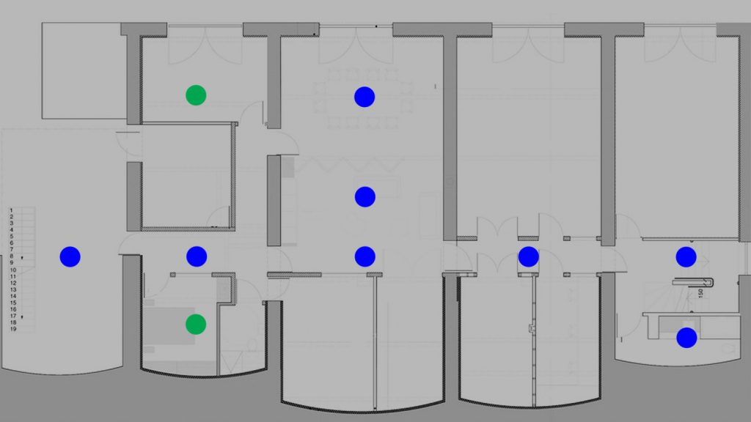

The building is easily accessible by bus and train from London. Gatwick airport is 30 minutes by train and London is 60 minutes.

Accessibility
The location of 20 Wellington Road is such that the studio is based two storeys below street level and is accessed by four flights of stairs. There is a continuous handrail and lighting throughout the stairwell. Wheelchair access to the studio is available Monday to Friday between 9am and 5pm and 9am to 1pm on Saturdays. There is a wheelchair accessible WC on site. While we are happy to encourage support workers to undertake the residency with you if required, although we can only offer accommodation for one person or a couple sharing.

Costs
The Residency Programme is managed by Blast Theory who undertake the upkeep and maintenance of the building. We ask that residents pay a nominal fee of £100 per week to cover these running costs.
Unfortunately we are unable to support travel or living expenses for your time with us.

Bursary scheme
We are able to subsidise a maximum of one residency per year through our bursary scheme, based on financial need. If you wish to apply for a bursary please outline your circumstances and demonstrate your need for the bursary in your application. We will give priority to full-time artists on low incomes who would otherwise not be able to afford the opportunity.

“When I applied for 20 Wellington Road, I imagined it as an opportunity to take some time and space, gather a few collaborators from around Europe, and "jam" on a particular manifestation of my artistic research in smell and interaction. Well, it was undoubtedly that. But perhaps even more crucially, my residency was a two-month object lesson in how one can live and work as part of a practising artist's group. Seeing Blast Theory in action every day, taking care of each other and making great work with gentle dedication, was just as valuable to my practice, and my life, as were the infrastructural and technical support of their team. I strongly recommend the 20 Wellington Road residency to any artist or artist group seeking a dose of practical and soulful inspiration.”
Heather Kelley

