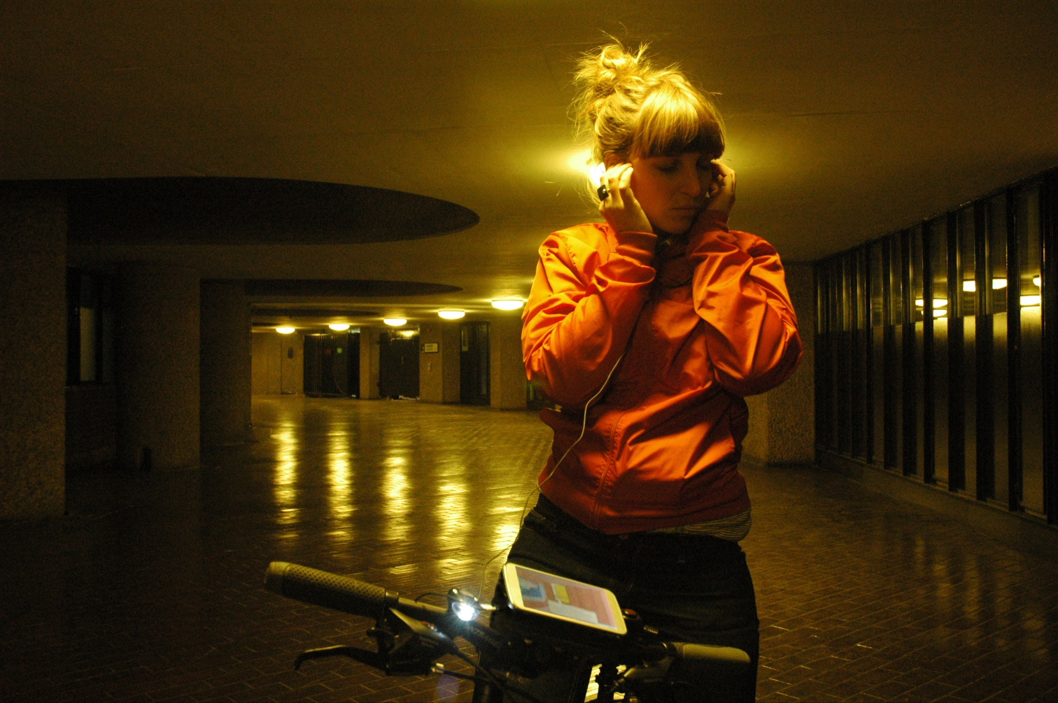

Software Testing and Accessibility

What we learnt testing Rider Spoke

Blast Theory 2021

Contents

About this resource 4
About Rider Spoke 6
The work 6
Artistic description 6
How it works 7
The redevelopment 8
Accessibility: what we wanted to achieve 9
Planning your tests 10
Setting test goals 10
Example test outline 12
Types of device testing 14
Finding an accessible location for testing 19
Recruiting testers with access needs 21
Who to test with 21
Disability in the UK 21
Writing an accessible job post 23
Sharing your call-out 25
Running your test 26
Liaising with testers in advance 26
Location accessibility 27
Additional support or adjustments 28
How we adapted for touring 30
Pre-production and working with touring partners 30
Ticketing and communication in advance 31
Front of house and assistance 33
Assistive technologies and equipment 36
Appendices 37
Example job call-out 37
Example Access FAQ for audiences 37
Example of other assistive technologies 38
About Blast Theory 41
Rider Spoke Artists’ Note 42
Further reading and resources 43

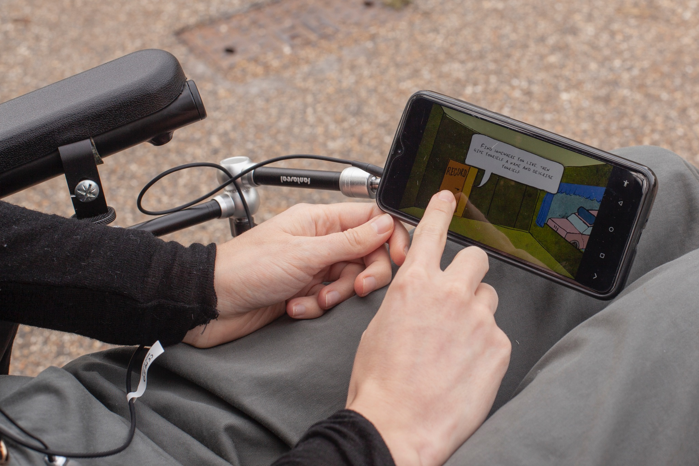About this resource

This resource shares what Blast Theory has learnt about accessibility testing software on artistic projects. We hope it will be useful if:

- You create software projects, artworks or services
- You want to reduce barriers for people with restricted mobility, hearing or vision
- In particular, we hope this resource will be helpful for arts organisations and the heritage sector

This resource uses a project called Rider Spoke as a case study. Rider Spoke is a software-led project for cyclists who ride alone, often at night, on public roads. It’s a challenging project for accessibility!

Led by Matt Adams, Ju Row Farr and Nick Tandavanitj, Blast Theory creates interactive art to explore social and political questions, placing audience members at the centre of our work. We work across performance, installation, apps, games and film. Winners of the Nam June Paik Art Center Prize, we’ve been nominated for four BAFTAs and have shown work at Tate Britain, the Venice Biennale, the Museum of Contemporary Art in Sydney and the Sundance Film Festival. In 2018, Blast Theory were the first Artists in Residence at the World Health Organization in Geneva.

In our experience accessibility requires time, resources and significant thought. By sharing what we have learnt, we hope to help you move more quickly to expand access elements in scale and ambition. We have found that there are always limits to what we can offer to those with access needs. But the work we have done is richly rewarding and we have seen immediate improvements in removing barriers to participation.

This resource is a case study based on what we learnt about accessibility testing software for Rider Spoke. It is not intended as a definitive guide. We are not experts in accessibility and throughout this document we have included links to additional resources and sources of expert advice. We’re always open to learning more if you have any comments, please get in touch via info@blasttheory.co.uk.

About Rider Spoke
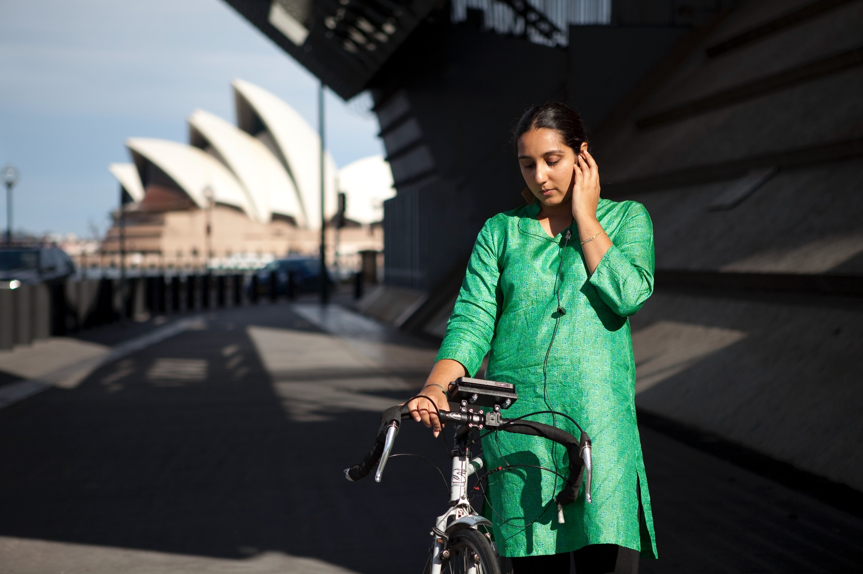Photo by Alex Kershaw

The work
In Rider Spoke you cycle alone through the city with a smartphone on your handlebars and a voice in your ear. You're asked questions about your life, searching for a place to hide your answer to each one. As you cycle, you get to choose: answer another question, or look for the hiding places of others and hear what strangers have to say.

Artistic description
To cycle alone, in the evening, with no particular destination, offers a rare freedom. In Rider Spoke this is combined with an opportunity to think about the people in your life and to share them with strangers who you will never meet. Guided by Ju Row Farr’s narration and a delicate score by Blanket, you can lose yourself for a while.

As you roll through the streets your focus is outward, looking for good places to hide, speculating about the hiding places of others, becoming immersed into this overlaid world as the voices of strangers draw you into new and unknown places. The recordings are only available in this context: played to you, alone, in the place where they were recorded.

The streets may be familiar but you’ve given yourself up to the pleasure of being lost.

How it works
Audience members book tickets online through the host’s website which includes accessibility information (ways to take part, a link to Access FAQs and contact information). We will cover this in more detail further down.

On arrival at the venue, a short verbal briefing introduces you to the project. A smartphone is provided (with a headset) which includes the terms and conditions for participation. Those who need additional assistance are asked to pre book an assisted ticket for a dedicated slot where staff have more time available to offer a customised experience at front of house, depending on access needs (see below).

If you have brought your own bike (or other personal transportation e.g. wheelchair or mobility scooter) we fit a special mount to this to attach the smartphone. Loan bikes are also offered for anyone who does not have a bike. Those on foot are provided with a phone on a neck strap and wireless headphones.

With a smartphone mounted to your handlebars, you head out on your ride. One earphone in, one ear tuned to the world around you, the voice in the app asks you one question at a time. The questions start gently, but grow more personal. When you choose to answer, you cycle to find the perfect place to make your recording – alone, in an out of the way spot, you reflect on your life. Your recording stays in that spot for other riders to find later.

You can also choose to look for the hiding places of others. Cycling as you search, the app shows you names of other riders and the questions they have answered nearby. You stop your bike in the hiding place of the person you’ve chosen, and listen.

The redevelopment
In 2020, we decided to redevelop the work from scratch (the first version was made before smartphones existed) and were curious to see how it works in a socially distanced world.

Since the redevelopment, Rider Spoke has been shown at Brighton Festival, Norfolk & Norwich Festival and 101 Outdoor Arts, with further UK and international gigs scheduled for 2021 and 2022.

Watch a video about the work here

Accessibility: what we wanted to achieve

The previous version of Rider Spoke had barriers to participation and we’d always wanted to address this. In particular, we saw an opportunity to make it more accessible for D/deaf participants, blind or visually impaired participants, wheelchair or alternative cycle users and those who want to take part on foot.

The redevelopment was a good opportunity to develop the work with assistive technologies, including:
- Screen reader/iOS Voiceover
- Captions mode
- Zoom mode on large-screen devices

We also wanted to improve accessibility in other areas of the project, including:
- Recruiting testers
- Working with festivals/hosts to plan accessibility options in advance
- Better systems for ticketing and sharing accessibility information
- Audience experience at front of house

We set aside a budget of around £3,000 and a period of 1 month to complete testing and develop the software with assistive technologies. This budget included Blast Theory staff time (4 staff members), Tester fees and freelance Developer fees, as well as some equipment, consumables and local travel. We paid Testers with access needs £30 per hour and offered to pay travel costs where this was a barrier to participation. We already owned the devices for testing so the equipment budget was under £50.

Planning your tests

Setting test goals

Top tip: Having a long lead up to any test is vital for accessibility. The more time you are able to give people in advance, the more time they have to plan and communicate their needs.

Testing and accessibility device testing are vital steps when developing a new website, web app or native app to ensure it works on a range of devices and is accessible for audiences.

Top tip: Testing a work for accessibility goes beyond ensuring the technology itself is accessible. The information you provide in advance, and the location where people take part in the work, must be accessible too.

For a new software project, we usually plan at least one usability test with test audiences, alongside regular click-through testing (more on this later). For Rider Spoke, we also added three tests for accessibility and assistive technologies. Although we had originally planned two tests in the same week, we ended up doing three tests over a month with a longer gap in between to give time for software development and to adapt the introductory script and testing location.

We now include accessibility testing as standard for all our new works and build this into our budget from the outset. Testing also helps track progress and check whether development milestones have been met.

Top tip: Good testing processes include multiple team members and are planned at the start of a project with a budget assigned to ensure testers are paid for their time where appropriate.

Test outline
To plan your testing, start with a test outline. Write it in advance of the test and update it as the development evolves. A good test outline focuses the team and ensures everyone is on the same page about the testing goals.
Your test outline should include:
- Purpose of milestone/test (be as precise as possible about what you are testing)
- Expected stage of software development (what will be ready to test and what will be outstanding)
- Internal team required (make sure you have everyone you need)
- Number of testers required (fewer is usually better but you want a range of experiences)
- Location of test
- Equipment required
- Feedback process
- Accessibility adjustments required e.g. assistive technologies or location adjustments for testers

Example test outline
Purpose of milestone/test | This is a usability test to get audience feedback on:  - App functionality  - Interface design and usability  - Front of house script and flow of front of house experience  - Covid safety measures  - Range of headset options
Expected stage of software development | Milestone 2 Beta  At this stage we will have a native mobile application that is:  - Provided as a standalone Android APK that can be installed locally.  - Compatible with Android 9 and greater  - Tested as working with a specified Android phone. Probably a 2020 Moto E  - Tested as working with wired and wireless Bluetooth audio headsets  - Tested as working with a server API which will be provided by us  - A Gitlab code repository, containing all application source code  - Documentation, giving specifications of any data structures and an introduction to the application structure and repository file system.
Internal team required | - 1 Front of House Performer  - 1 Front of House Assistant  - 1 Bike Wrangler  - 1 Artist to oversee and run feedback sessions  - 1 Developer
Number of testers required | 5 -10 people
Location of test | Blast Theory studio in Portslade, outdoor terrace
Equipment required | - A phone for each tester  - Headphones  - Bike mounts  - Bikes  - Bike racks  - Seating area for feedback  - Table and chairs for reception desk  - Umbrellas  - Gazebos  - Water and cups  - Masks  - Hand sanitiser  - Antibacterial wipes  - Antibacterial spray  - Rubbish and recycling bins  - Clipboards  - Pens  - How to take part cards  - Emergency number cards
Feedback process | One on one verbal feedback with a set list of questions. Blast Theory team to hand write feedback on a printed form.
Accessibility adjustments required | This test is not specifically for assistive technologies, however we will make adjustments as required when Testers and their access needs are confirmed. This may include, but is not limited to:  - Ramp available for front door  - Large print text  - Staff available to accompany Testers or employing a BSL interpreter  - Accessible toilets available nearby  - Identify a safe drop off point nearby

Types of device testing

We use three types of test:
- Click-through tests - systematic tests designed to check the software works as expected and meets specifications - including the design specifications.
- Usability tests - to evaluate the software with representative users. These will need adapting depending on the project.
- Assistive technology tests - similar to ‘Click-through’ and ‘Usability’ tests, but using specific assistive technologies such as screen readers, and/or accessibility auditing tools.

Now, let’s look in more detail at these three approaches:

What are click-through tests?
Click-through testing runs a standard set of checks on software to confirm that the software works as expected. Do click-through tests on a number of different devices (or browsers) to check for issues across different operating systems and hardware.

For Rider Spoke we lend our phones to audiences as part of the experience, so the application is not on the App Store. We used iPhones and iPads as we found they were better suited to assistive technologies; they have clear, bright screens; and there are fewer versions of the operating systems. Apple devices also tend to be reliable. By focusing on a single operating system, we reduced the complexity of our software development.

For projects where the public use their own devices, we support older versions of OS and test across a range of computers, phones and tablets above this threshold. We specifically include budget and older phones within these tests so that audiences who don’t own expensive devices are not excluded from taking part.

We also use Browserstack for remotely testing on different hardware and browser platforms: http://browserstack.com

A test spreadsheet gives a step by step list of actions and expected responses from the software. Here’s an example:
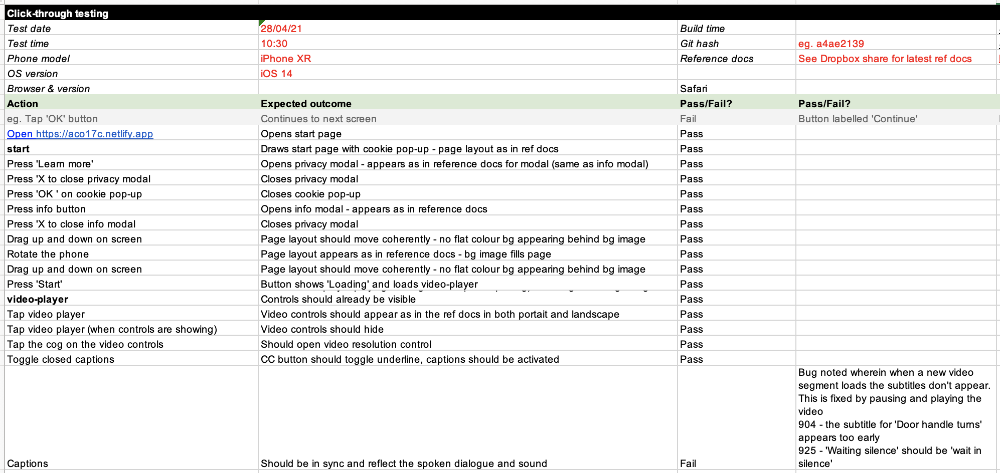

As you find specific issues, add them to the spreadsheet to check that these issues have been resolved in future tests. We also report these to the Developer via Gitlab (as it is the platform they use for organising their workflow).

Top tip: Repeat click-through testing every few days throughout the development process to ensure that no bugs are introduced as you move forwards.

What are usability tests?
Usability tests evaluate a product or service by testing it with representative users. Usually, during a test, participants will try to complete typical tasks while observers watch, listen and take notes. When tests are done online, remote testers give feedback through an online form, video call or recording of their screen. The goal is to identify any usability problems, collect qualitative and quantitative data and determine the participant's satisfaction with the product. When testing in person we also test how any verbal instructions, specific locations or equipment are working (see below ‘Finding an accessible location for testing’ for more details).

We usually run usability or user tests ourselves to test new work. We do them at different stages of development with different cohorts of testers - depending on the needs of the project.

For example, early on we may test with members of our team, friends or associates: they are critical friends who will make allowances for big problems. Or we may make an open call through our social media to invite users to test online work remotely: this group is more representative of final users. Tests are often linked to project milestones, with test feedback providing material for milestone reviews.

For Rider Spoke, we ran a usability test with 5-10 local people, who were invited to take part via a social media call out and via email (for friends and associates). These testers were volunteers and were reimbursed for travel costs only. As well as testing the recent redevelopment of the app, we tested our introductory script to the work with social distancing in place.

Assistive technology tests
“The phrase 'assistive technology' is often used to describe products or systems that support and assist individuals with disabilities, restricted mobility or other impairments to perform functions that might otherwise be difficult or impossible.”
Source: Gov.uk

For Rider Spoke we ran device testing for accessibility by testing Apple devices with iOS VoiceOver, captions mode and large text/zoom. Testing with a screen reader/iOS VoiceOver follows the same pattern as click-through testing but with an adapted testing sheet.

The Rider Spoke app was developed using React Native. Unfortunately, we found that a limitation in React Native’s implementation of iOS Voiceover caused issues for screenreader users. And after feedback from a visually impaired tester, we also found that for this project in particular, an audience member may need to be accompanied and guided through the experience to make the app usable. We therefore could not offer a screen reader option but instead offered assistance from front of house staff to accompany participants or bring their own Personal Assistant.

Top tip: We follow WC3’s accessibility standards. For web-based projects we also test that web pages are compliant with WC3’s accessibility standards.

We run tests on a desktop browser with a browser plug-in called aXe.

There are a wide range of other assistive technologies out there for accessing web or mobile applications. Please see the appendices for more information.

Resources
- Apple’s VoiceOver support page: https://support.apple.com/en-gb/guide/iphone/iph3e2e415f/ios
- How to navigate your iPhone with VoiceOver: https://www.youtube.com/watch?v=qDm7GiKra281
- WC3’s accessibility standards: https://www.w3.org/WAI/standards-guidelines/wcag/

Finding an accessible location for testing

For Rider Spoke we ran our first test from an outdoor terrace at our studio in Portslade. This location is on a busy main road and proved to be a challenging starting point for testers because of the loud road noise, lack of shelter from the weather and a camber in the pavement.

After feedback from our first test we decided to run remaining tests at Pavilion Gardens in central Brighton: a much quieter, more familiar and accessible location.

Top tip: When finding an accessible location it’s vital that you make at least one site visit to check details in person.

Some things to consider include:
- Step-free access with lifts and ramps. It can be difficult for electric wheelchairs to travel in a perfectly straight line, so the ramp should fill the width of the door to ensure that they don’t slip down the side.
- Wide doorways, corridors or pathways with even ground
- Comfortable seating
- Tables at an appropriate height for wheelchair users
- Emergency evacuation procedures with assistance
- Accessible toilets - ensure you visit the toilets yourself to check for location, condition and if they need to be unlocked by someone
- Accessible parking spaces or a safe drop off point - check this is close by and available
- Accessible signage - this might include braille or large print
- Adequate lighting and heating
- Shelter and weatherproofing (if working outdoors)

This is by no means a full list of location considerations. To find out more you can review other resources or seek advice from a consultant who can visit your venue and give advice. Attitude is Everything have a fantastic Access Guide: Reopening your Venue.

Recruiting testers with access needs

Who to test with

Disability in the UK

For Rider Spoke we aimed to remove barriers to participation for the large population of disabled people in the UK and open a discussion around accessibility with each host/festival we work with.

“Disabled people make up about 1 in 5 of the British population and 14.1 million people are disabled in the UK.

The prevalence of disability rises with age. Around 8% of children are disabled, compared to 19% of working age adults and 46% of adults over State Pension age.”

Source: Family Resources Survey (2019 to 20)

Attitudes
- 1 in 3 disabled people feel there’s a lot of disability prejudice.
- 1 in 3 people see disabled people as being less productive than non-disabled people.
- In 2000, 37% of disabled people and 34% of non-disabled people felt that there was a lot of prejudice around disability. The gap trebled by 2017, with 32% of disabled people and 22% of non-disabled people feeling there is a lot of prejudice against disabled people. “
Source: Scope: Disability Perception Gap (2018)
Rider Spoke Testers

When testing Rider Spoke we did a public call out for three testers:
- A wheelchair (or alternative cycle) user for testing with mount on their chair
- A blind person or someone with a visual impairment for testing with a screen reader/iOS VoiceOver
- A D/deaf person or someone with a hearing impairment for testing with captions mode

In this case some testers had multiple diverse access needs including limited mobility, visual impairments, hearing impairments, neurodiversity, chronic illness and sensory sensitivity.

When offering accessible options, it’s important to understand that disability is complex and everyone's needs are different. For example, by testing with one person who is D/deaf it does not mean that just because it worked for that individual, it will be suitable for all people who are D/deaf. So try to test with a range of different people and be ready to keep learning once the work is open to the public.

Top tip: When sharing access information, state clearly what is on offer to enable that person to decide for themselves if the experience is accessible for them. Be open to questions, learn from every enquiry and consider making further adjustments.

We considered working with a consultant and got quotes from local organisations to recruit testers and facilitate testing, but in the end decided to run the tests ourselves. This enabled us to be more in control of the process and work more closely with testers, and hear their feedback directly. Whilst outsourcing to an experienced consultant may be a good option for larger organisations or more complex tests, we found that taking charge of the process ourselves helped to develop our own insights and skills. We now embed our learnings from the outset in our recruitment, project planning, budgeting and creative development processes.

Writing an accessible job post

In a recent survey done by Attitude is Everything with more than 50 people working in the music or live events industry who identify as D/deaf, disabled, neurodivergent or who have a physical or mental health condition “51% had withdrawn from a job application process due [to] accessibility related reasons”. It’s vital that accessibility is a key consideration at every step of recruitment, from the first entry point of someone hearing about the role, and that this is made clear in the job listing.

Source: Attitude is Everything
Some considerations for creating an accessible job listing include:
- Accessible and inclusive language e.g. simple words and sentences, friendly and warm language, weeding out jargon/insider talk
- Access information for interviews/locations
- Examples of adjustments that can be made e.g. allowing more time for interviews, breaks, sending questions in advance or having a sign language interpreter
- A team contact to get in touch with for any questions
- Large print versions of any downloadable documents in Microsoft Word format (this is a preferred format for screen readers)
- A range of ways for people to apply e.g. online form, video, audio recording or phone call. In particular, we found that offering applications by phone greatly improved accessibility as making an audio or video recording can be daunting for applicants

We have included an example of our call-out for app testers with access needs in the Appendices.
Resources
- Attitude is Everything has a great guide about Accessible Employment
- Scope also has some useful resources about language when referring to disabilities

Sharing your call-out
Ensure you leave a long lead time (at least 1 month) for any call-out to allow for any adjustments or for candidates to get assistance with their application.

Some places to share testing jobs are:
- Disability Arts Online
- Arts Jobs
- Jobcentre Plus
- The Other Box (paid)
- Local organisations or charities including D/deaf and blind groups. Give them a call and follow up with an email with a document for them to circulate or a flyer/poster for notice boards. If given enough time they may be able to share in newsletters.
- Your Facebook and Facebook groups
- Twitter
- Instagram

Examples of great arts organisations working in this area are:
- Deafinitely Theatre
- Graeae
- Birds of Paradise Theatre

Running your test
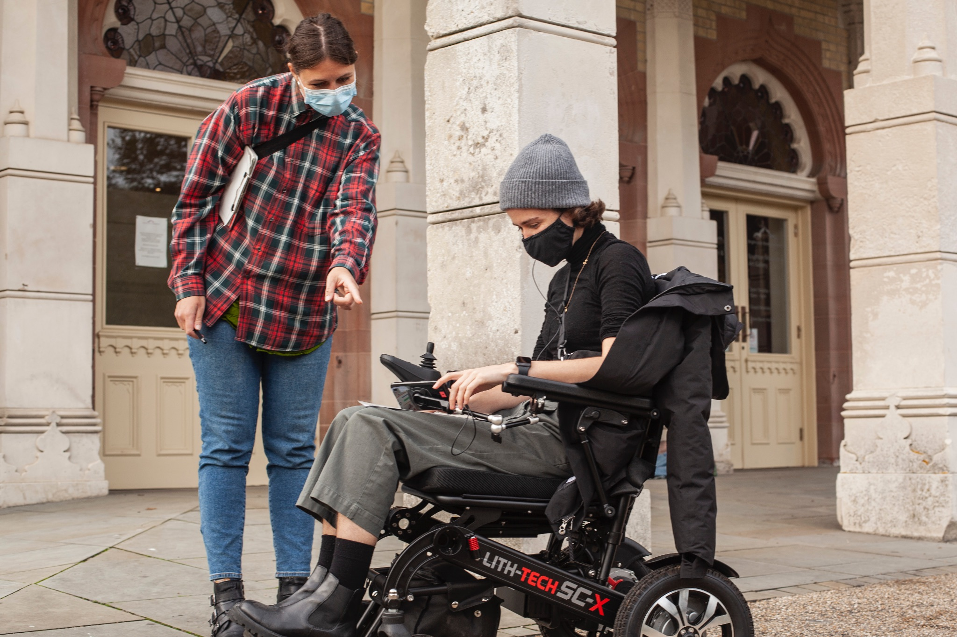

Liaising with testers in advance

Top tip: Share key information with chosen testers in advance so they know what to expect and you know how to prepare to accommodate any access needs. You can give information in person or send it as email instructions.

Information to share includes:
- Details about the status of the work, e.g. is it complete? What are the known issues?
- Requests in advance to pay attention to specific areas, e.g. timing, language
- Constraints about the test, e.g. time or device limits
- Method of feedback, e.g. online feedback form, verbally in person or on a video call
- What to bring
- Your contact details
- Safety information, e.g. social distancing measures
- Accessibility Information
  - Details on the accessibility of the location (see below)
  - Details of additional support or adjustments you can provide (see below)

Location accessibility

Tell potential testers about the testing location in detail. Share information on:
- Wheelchair and step free access:
  - Width of doors, corridors or pathways
  - Condition of pavement/entrance e.g. note a camber in the road and that there is limited space to turn and not much run up
  - Width, length and type of the ramp. It can be difficult for electric wheelchairs to travel in a perfectly straight line, so the ramp should fill the width of the door to ensure that they don’t slip down the side. Ask for details on the tester’s wheelchair so you can find a location that is accessible
  - Send photos as needed
- Local transport links, disabled parking bays and suggested drop off points where you can meet them
- Accessible toilets nearby
- Covid-19 and other health and safety measures
- Expected weather forecast (ask if people felt comfortable to take part)
- Options for testing and feedback indoors and outdoors
- Contact details for meeting them onsite

Additional support or adjustments

Ask for more detail on their access requirements to make it clear before arrival what you can do to support.

Top tip: Communicating and discussing access needs can be a difficult and exhausting process for many disabled people. Giving some examples of what you can offer helps to reduce the work for them and communicates clearly that you are open to making adjustments.

It’s important for you to share key access information with other members of your team so they know what to expect and the tester doesn’t need to repeat themselves.

For longer-term roles, the tester may want to complete an Access Rider to give more details about their needs (see appendices for an example).

- Give examples of what you can offer, which may include:
  - Reading out transcripts of text in full so they don’t have to read long text on screen
  - Employing a BSL Interpreter to assist
  - Verbal feedback instead of written feedback
  - Allowing time for regular breaks and toilet trips
  - Meeting them at bus stop, outside the building or at a drop off point
  - Arranging for a sign language interpreter or personal assistant to attend
- Ask what experience they have with access technologies and what device they use day to day. For example: a visually imapired person may have never used a screen reader before and may use zoom mode.
- Send information on font sizes to identify what is suitable for print-outs or on-screen text
- If you are planning to take photo/video documentation, check they are comfortable with this
- Offer assistance preparing invoices
- Share your contact number to discuss further on the phone if preferred

How we adapted for touring

After testing Rider Spoke for use by audiences with diverse access needs we adapted our offer to audiences. With support from the host/festival, we invite audience members to take part on a bicycle, wheelchair, mobility scooter, alternative cycle or on foot. We also offer some assistive technologies, suggested routes and additional assistance.

Pre-production and working with touring partners

- Discuss accessibility with the host in advance to review options and find out more about accessibility, policies and staff support across the festival/event.

For Rider Spoke we had a positive response from hosts. For example, Norfolk & Norwich Festival shared our focus on improving accessibility and recruited access champions to work as part of the Rider Spoke front of house team and give additional support where needed. They also used local knowledge to create an accessible route map of the area.

- Plan testing on the ground and invite people with access needs to test the work on site ahead of opening.

For Rider Spoke, Norfolk & Norwich Festival helped to recruit wheelchair users for the dress rehearsal, who gave vital feedback on the experience and accessible route map.

Ticketing and communication in advance

- Put accessibility information front and centre on the booking page, including a link to an Access FAQ.

For Rider Spoke we created an Access FAQ for the booking page to share key information about the work and access considerations, so each individual can make up their own mind about whether it is accessible for them and ask any questions in advance. See appendices for an example of our Access FAQ.

- Ensure box office contact information is available for discussing any accessibility requirements or questions

- Share key information with box office staff so they are confident to advise on options available

- Create a clear system for capturing any notes on audience access needs when people are booking, so these are passed to front of house staff daily

- Offer assisted slots where front of house staff can accompany an audience member during the experience and provide additional assistance

For Rider Spoke we offered one assisted slot per day, making it clear that our staff are not trained Personal Assistants but could offer the following assistance:

- Reading out the introductory briefing, explaining the terms and conditions, and answering additional questions about taking part
- Accompanying audience members on foot during all or part of the experience
- Assisting audience members to operate the smartphone and the app
- Guiding audience members on an accessible route around the local area
- Showing audience members where accessible toilets are located

Following feedback that Testers preferred to take part during daylight, we decided to offer this slot as the first booking window for the day. We decided to offer one slot initially and then stand ready to increase capacity based on demand.

- Offer a free ticket for Personal Assistants

For Rider Spoke, all festivals were able to offer this and already had it as part of their policy. For D/deaf participants this person could be a BSL Interpreter.

- Give local accessible transport and toilet information

For Rider Spoke at Norfolk & Norwich Festival this included:

Local accessible transport information
There are buses which stop a stone’s throw away from the park entrance on Theatre Street (opposite the Theatre Royal, and also others near M&S). On St Stephen’s Street (the road at the bottom of Theatre Street, which is arguably the main ‘high street’) there are a multitude of bus stops where the majority of city-bound buses stop. Just off of St Stephen’s Street is Norwich bus station – if buses don’t stop on St Stephen’s Street or Theatre Street, they’ll stop here.

Local accessible toilets information
Rider Spoke audiences will be able to use our own accessible toilets within Chapelfield Gardens (where the starting place is for the event). We will make sure that our volunteers and yourselves all know where to direct people to. Alternatively, Chantry Place (a well-known shopping centre couple mins walk away) has multiple accessible toilets and a Changing Places toilet.

- Ensure the venue or outdoor space is accessible and share any location specific information that may limit accessibility. Share photos of the site where possible, particularly areas with uneven ground, ramp access, slim doorways or paths.

Front of house and assistance

- Make it clear what to expect when audience members arrive by writing a step by step walkthrough of what happens during the experience.

For Rider Spoke we described what participating involves:
- On arrival at the venue, we provide a short verbal briefing (about 2 minutes) to introduce taking part and ask you to read and agree the terms and conditions for participation on a smartphone.
- To take part, we provide a smartphone with an app and headset. If you have brought a bike (or other personal transportation) we fit a special mount to this to attach the smartphone.
- You are then invited to explore an area around the venue on your bike, using the app as a guide. App provides on-screen text prompts and a narration which plays through the headset.
- The narrator asks you questions and invites you to choose locations to record answers to these. You record answers by tapping the screen at the prompts and speaking into the headset.
- After answering your first question you’re given the option to listen to recordings made by other participants at that location.
- From this point, you can choose freely between answering questions or listening to other participants’ recordings.
- After 45 minutes the narrator prompts you to make a final recording before asking you to return to the venue. You can take as long as you need to return.
- On arrival, you return any equipment that you’ve borrowed. We may, at this point, ask you to give verbal or written feedback on your experience. This is optional.

- Describe assistance and adjustments that can be provided by front of house staff at the venue

For Rider Spoke, this included:
  - A printed version of the introductory briefing, including a large print version of this
  - A printed version of the Terms & Conditions, including a large print version
  - We also offered to read out or summarise the Terms & Conditions

- Describe assistance and adjustments that can be provided in the local area

For Rider Spoke this included:
  - Space for Personal Assistants to accompany participants at no cost
  - A map with a suggested route that was wheelchair accessible
  - Advice on quieter areas for non-confident cyclists
  - An assistant from our team to accompany participants (on foot only) for some or all of the experience

- Explain ways to take part

For Rider Spoke we gave options for the audience to take part on a bicycle, alternative cycle, mobility scooter, wheelchair or on foot. Depending on their preference, we offered to install a mount for attaching the smartphone or give a neck strap to hold the device.

Assistive technologies and equipment

- Explain assistive technology options on offer and who these might be suitable for

For Rider Spoke this included the following information:

Participants are provided with a smartphone, app and headset. The app shows text prompts on-screen (12pt in a handwritten script font) and has audio narration that plays through a small earbud style headset.

For those with visual impairments, we offer:

- A more legible sans-serif font for some on-screen prompts.
- An iPad with a larger 10.9” display and optionally using iOS’s Zoom feature. This is for participants on foot only and is provided with a neck strap and wireless headset.

For those with hearing impairments, we offer:

- On-screen transcripts of the audio narration. However, there are no transcripts for recordings made by other participants. These are only accessible via audio.
- An iOS14 phone with Bluetooth for connecting participant’s own compatible audio device where they have one.

- Explain assistive equipment options on offer

For Rider Spoke this included:
- An iPad with a larger 10.9” display and optionally using iOS’s Zoom feature
- A limited number of iOS14 phones with Bluetooth that may allow you to connect your own audio device if you have one that is compatible
- A phone mount suitable for a wheelchair or mobility scooter
- A range of phone mounts suitable for bikes or alternative cycles
- A phone case with neck strap

Appendices

Example job call-out
Here is an example of a job call-out for app testers with access needs in 2020:
https://www.blasttheory.co.uk/wp-content/uploads/2020/09/Call-out-for-app-testers-with-access-needs_-2.pdf

Example Access FAQ for audiences

Here is an example of our Access FAQ for Rider Spoke at Norfolk and Norwich Festival in May 2021:
https://www.blasttheory.co.uk/presentations/rider-spoke-norfolk-and-norwich-festival/

Example of other assistive technologies
Source: Surface Impression
There is a wide range of assistive technologies that will enable users to access their computer programs and to access the web depending on their access needs. We’ve listed some of the most common ones:
- Alternative keyboards featuring larger- or smaller-than-standard keys or keyboards, alternative key configurations, and keyboards for use with one hand.
- Electronic pointing devices used to control the cursor on the screen without the use of hands. Devices used include ultrasound, infrared beams, eye movements, nerve signals, or brain waves.
- Sip-and-puff systems activated by inhaling or exhaling.
- Wands and sticks worn on the head, held in the mouth or strapped to the chin and used to press keys on the keyboard
- Joysticks manipulated by hand, feet, chin, etc. and used to control the cursor on screen.
- Trackballs, movable balls on top of a base that can be used to move the cursor on screen.
- Touch screens allow direct selection or activation of the computer by touching the screen, making it easier to select an option directly rather than through a mouse movement or keyboard. Touch screens are either built into the computer monitor or can be added onto a computer monitor.
- Braille embossers transfer computer generated text into embossed Braille output. Braille translation programs convert text scanned-in or generated via standard word processing programs into Braille, which can be printed on the embosser.
- Keyboard filters are typing aids such as word prediction utilities and add-on spelling checkers that reduce the required number of keystrokes. Keyboard filters enable users to quickly access the letters they need and to avoid inadvertently selecting keys they don't want.
- Light signaller alerts monitor computer sounds and alert the computer user with light signals. This is useful when a computer user cannot hear computer sounds or is not directly in front of the computer screen. As an example, a light can flash alerting the user when a new e-mail message has arrived or a computer command has completed.
- On-screen keyboards provide an image of a standard or modified keyboard on the computer screen that allows the user to select keys with a mouse, touch screen, trackball, joystick, switch, or electronic pointing device. On-screen keyboards often have a scanning option that highlights individual keys that can be selected by the user. On-screen keyboards are helpful for individuals who are not able to use a standard keyboard due to dexterity or mobility difficulties.
- Reading tools and learning difficulties programs include software and hardware designed to make text-based materials more accessible for people who have difficulty with reading. Options can include scanning, reformatting, navigating, or speaking text out loud. These programs are helpful for those who have difficulty seeing or manipulating conventional print materials; people who are developing new literacy skills or who are learning English as a foreign language; and people who comprehend better when they hear and see text highlighted simultaneously.
- Refreshable Braille displays provide tactile output of information represented on the computer screen. A Braille "cell" is composed of a series of dots. The pattern of the dots and various combinations of the cells are used in place of letters. Refreshable Braille displays mechanically lift small rounded plastic or metal pins as needed to form Braille characters. The user reads the Braille letters with his or her fingers, and then, after a line is read, can refresh the display to read the next line.
- Screen enlargers, or screen magnifiers, work like a magnifying glass for the computer by enlarging a portion of the screen which can increase legibility and make it easier to see items on the computer. Some screen enlargers allow a person to zoom in and out on a particular area of the screen.
- Screen readers are used to verbalise, or "speak," everything on the screen including text, graphics, control buttons, and menus into a computerised voice that is spoken aloud. In essence, a screen reader transforms a graphic user interface (GUI) into an audio interface. Screen readers are essential for computer users who are blind.
- Speech recognition or voice recognition programmes allow people to give commands and enter data using their voices rather than a mouse or keyboard. Voice recognition systems use a microphone attached to the computer, which can be used to create text documents such as letters or e-mail messages, browse the Internet, and navigate among applications and menus by voice.
- Text-to-Speech (TTS) or speech synthesizers receive information going to the screen in the form of letters, numbers, and punctuation marks, and then "speak" it out loud in a computerized voice. Using speech synthesizers allows computer users who are blind or who have learning difficulties to hear what they are typing and also provide a spoken voice for individuals who cannot communicate orally, but can communicate their thoughts through typing.
- Talking and large-print word processors are software programs that use speech synthesizers to provide auditory feedback of what is typed. Large-print word processors allow the user to view everything in large text without added screen enlargement.
- TTY/TDD conversion modems are connected between computers and telephones to allow an individual to type a message on a computer and send it to a TTY/TDD telephone or other Baudot equipped device.

About Blast Theory
Blast Theory creates interactive art to explore social and political questions, placing audience members at the centre of our work.

Led by Matt Adams, Ju Row Farr and Nick Tandavanitj, the group creates interactive art drawing on popular culture, performance, technology and games, the work often blurs the boundaries between the real and the fictional.

In virtual and physical spaces from pubs, canals and abandoned warehouses to libraries, museums and apps – we go to unexpected places to make our work accessible to everyone.

www.blasttheory.co.uk
@blasttheory

Rider Spoke Artists’ Note
Blast Theory, 2007

The design for the app uses imagery drawn from Mexican votive painting, sailor tattoos and heraldry: swallows flutter across the screen to show available hiding places, prefab houses indicate places where others have hidden. Votive paintings express gratitude (or sometimes a request) to a saint. Tattoos and heraldry are both badges of identity; early tattoos were hard won symbols of belonging, often indicating an achievement for a sailor. Sometimes they showed how far you had sailed. Sometimes they were expressions of hope for a safe return from a voyage. This combination of styles reflects Rider Spoke’s themes of travel, reflection, personal expression and hidden messages.

Rider Spoke explores where theatre may be sited and what form it may take. It invites the players to be co-authors of the piece and a visible manifestation of it as they cycle through the city. It is precisely dependent on its local context and invites the audience to explore that context for its emotional and intellectual resonances.

------

Rider Spoke was first shown at the Barbican in London in October 2007 and has subsequently been presented in Adelaide, Athens, Brighton, Bristol, Budapest, Cambridge, Copenhagen, Edinburgh, Falmouth, Kupio, Leeds, Linz, Liverpool, Madrid, Sydney and Terni.

Rider Spoke is sponsored by Trek and was developed in collaboration with the Mixed Reality Lab at University of Nottingham, Sony Net Services and the Fraunhofer Institute as part of the European research project IPerG (Integrated Project on Pervasive Gaming).

Further reading and resources

- A Disability History Timeline by NHS
- Ticketing without Barriers by Attitude is Everything
- Attitude is Everything Disability Equality Training for Live Events - a 2 week online course (Falmouth University)
- Access Rider by Disability Arts Online

